Guided Capstone Project Report
Big Mountain Resort: Pricing Strategy & Revenue Optimization

Problem Statement
The purpose of this analysis was to evaluate ticket pricing strategy for Big Mountain Resort by leveraging data science technical skills to estimate competitive market prices and for revenue optimization scenarios. The resort recently invested $1.54 million in a new chairlift and then aimed to maximize revenue while being competitive in the market. From the problem statement to ongoing forward I concluded a report for numerous findings from data wrangling, exploratory analysis, preprocessing, and modeling to determine the best step approach moving forward for Big Mountain in the resort industry.

Data Wrangling
The dataset initially had 330 rows and 27 columns, representing ski resorts with features such as ticket prices, amenities, and terrain characteristics. After cleaning, removing missing or redundant data, and keeping only the necessary features, the final dataset narrowed down to 227 rows and 25 columns. In this step we narrowed the ticket price to keep, we dropped the AdultWeekday ticket price due to more empty data, and only one was necessary to provide model predictions, being the AdultWeekend ticket. This step was crucial since dealing with data keeping redundant data is unnecessary, showed for less skew in graphs, and keeping relevant features by removing outliers allowed for gaining insights that is valuable for business analysts.
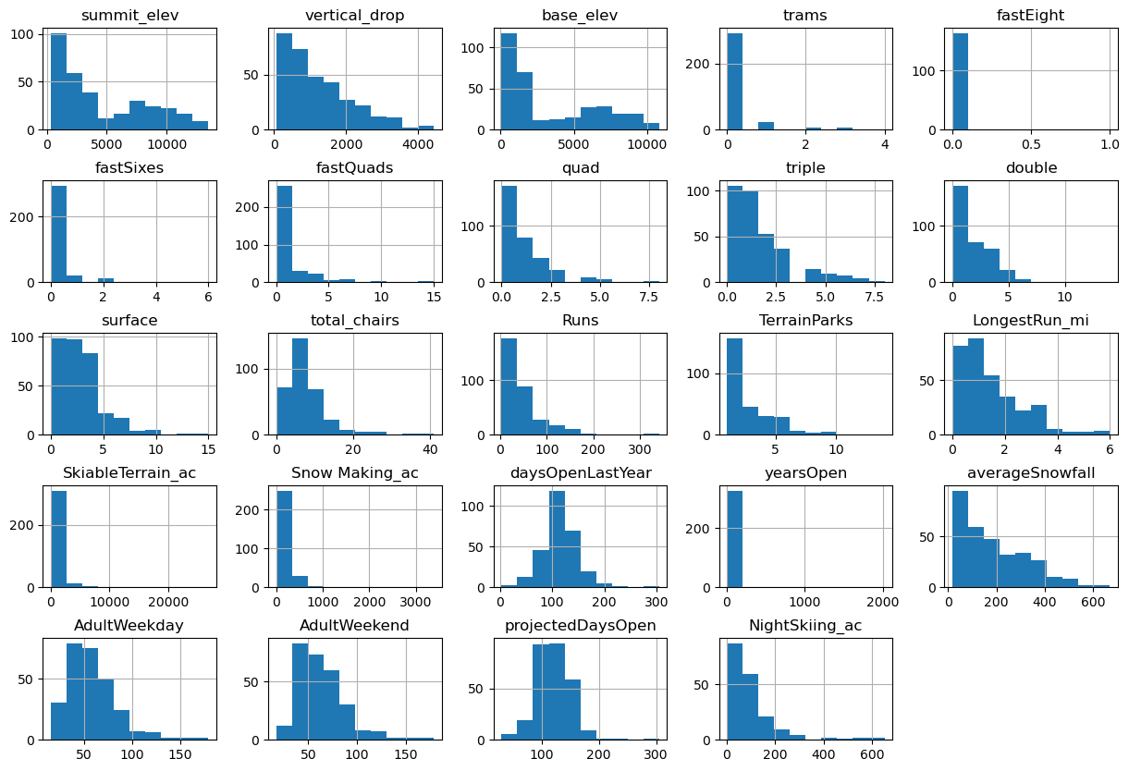

Exploratory Data Analysis
Exploratory data analysis (EDA) was conducted to uncover trends in ticket pricing. Through data visualization such as heatmaps and scatter plots, we discovered correlations and relationships between features and amenities. In order to have the best feature selection for modeling, we used standardization and principal component analysis (PCA) for most influential predictors. A strong positive correlation was observed between vertical drop, fast quad lifts, number of runs, total chairs, and ticket price; these amenities impacted pricing noticeably.
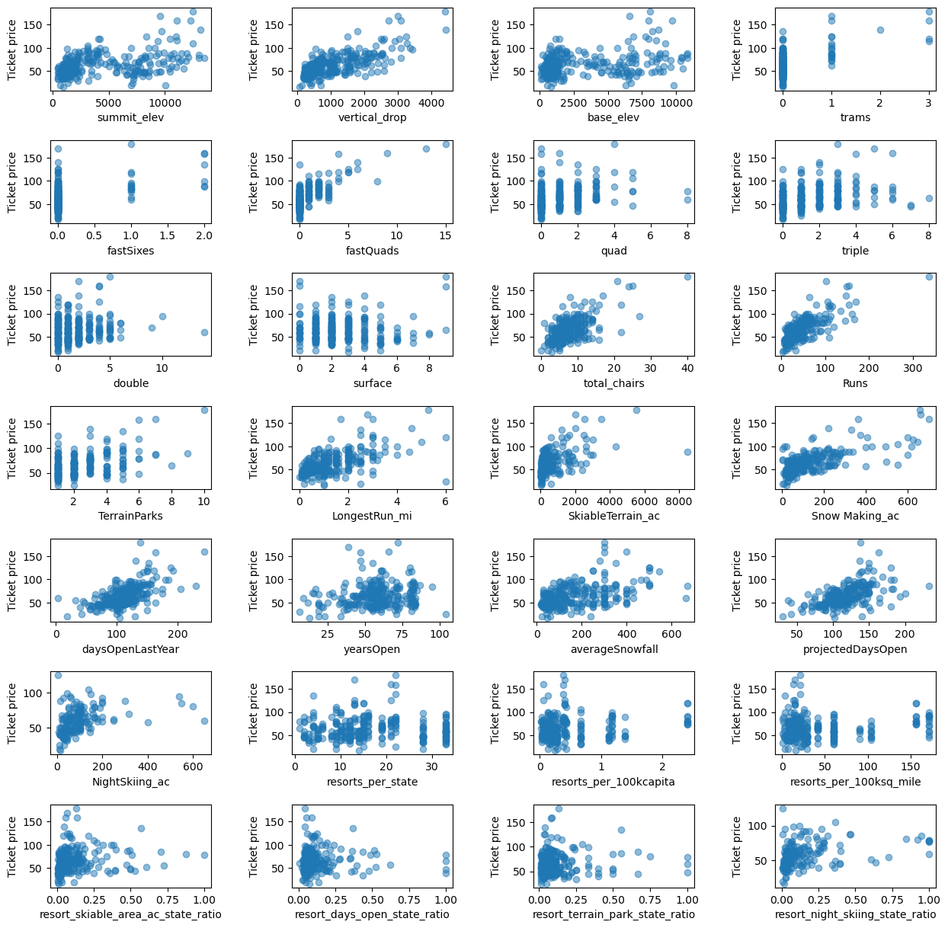

Model Preprocessing & Training
In this notebook, the most critical process was a machine learning pipeline, for imputation of missing values, feature scaling, and model selection. The target variable was Adult Weekend ticket price, chosen for its industry relevance.
- Linear Regression: This model performed lower due to non-linear relationships in the data.
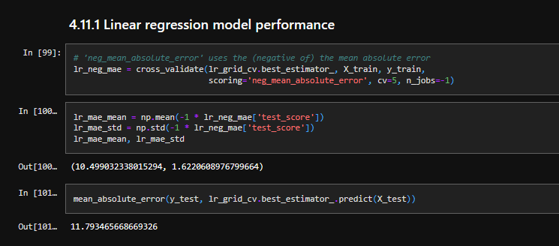
- Random Forest Regressor: This model provided more accurate predictions by capturing complex interactions between variables.
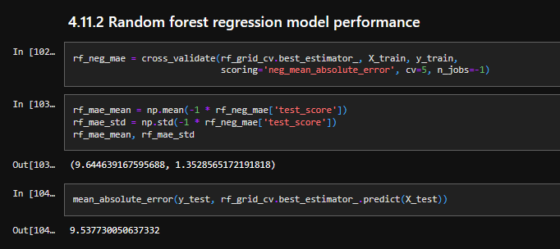

Cross-validation proved that the Random Forest model was superior to Linear Regression due to having a Mean Absolute error of almost $1, showing that the ticket price was close to the actual ticket price.

Modeling for Pricing Recommendation
The model predicted that the best optimal market ticket price for Big Mountain Resort should be $95.87, higher than the actual ticket price of $81. With an expected error of ±$10.39, the price could reasonably range between $85.48 and $106.26. Given this information regarding data-driven pricing, Big Mountain may be undercharging relative to market expectations.

Modeling Scenarios
In addition to pricing adjustments, several revenue-optimization scenarios were tested:
- Closing Least Used Runs
Closing one run had no impact on price, Closing 2 runs caused revenue losses, and closing runs 3-5 proved no change, ($700,000 - $2.3M). Reducing operational costs by closing runs may be beneficial for efficiency
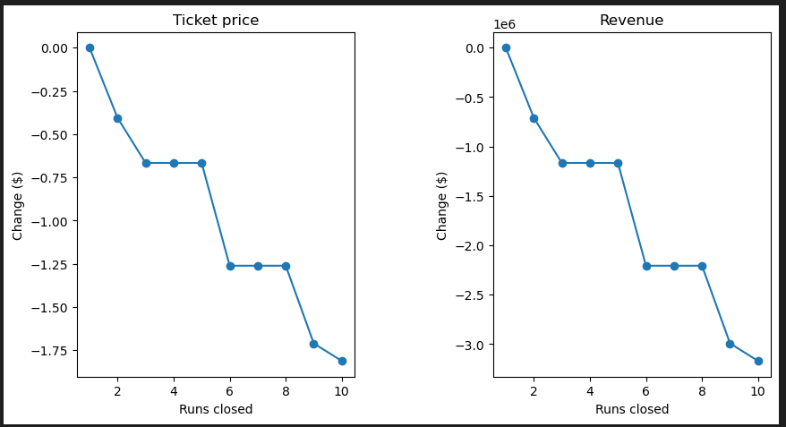
- Increasing Vertical Drop by 150 ft & Adding a Chair Lift
Increased ticket price by $1.99. Estimated additional seasonal revenue of $3,474,638. This scenario offered the best financial gain.
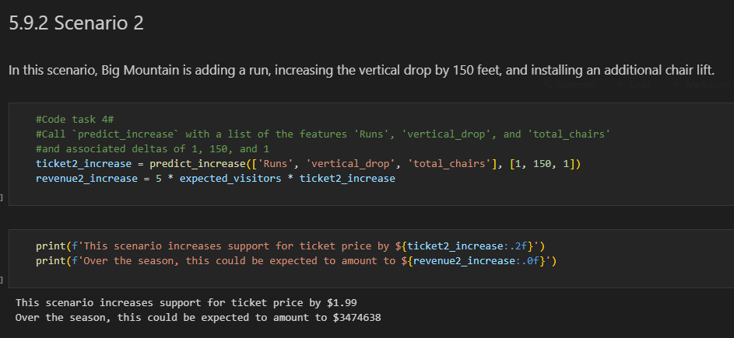
- Adding 2 Acres of Snow Making
No additional impact on ticket price or revenue, same as previous.
- Increasing the Longest Run by 0.2 Miles
No impact on ticket price or revenue, it is unnecessary and would harm the revenue.

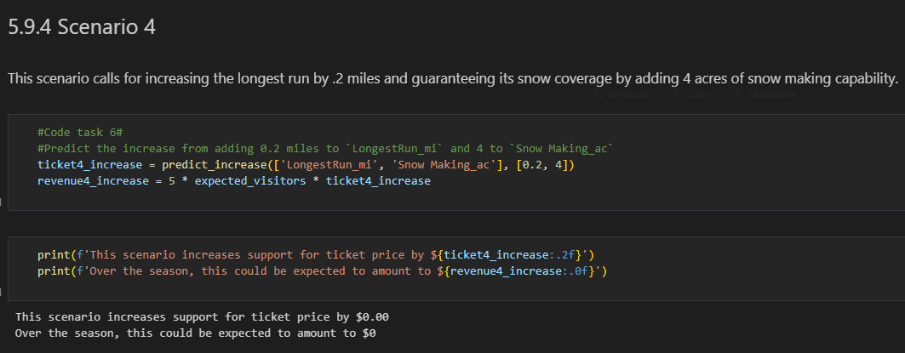

Further Steps & Conclusion
Based on the analysis, the best approach for Big Mountain Resort is to increase ticket prices that align with the market and invest in increasing the vertical drop along with adding a chairlift. As well as keeping track of visitor demand trends dynamically, optimize operational costs data, and staying on top of market trends for pricing updates.This is an efficient strategy for maintaining competition and revenue growth while fully utilizing its current facilities.

A dynamic dashboard could be developed, to hypothetically allow analysts to test pricing scenarios in real-time and make data-driven decisions.



